- Manhattan
  - With this dataset, I want to look at the relationship between square feet and price. This is very obviously a positive correlation with a larger square footage meaning a higher price. I also want to look at the relationship between price and zip code. Since we are looking at a specific area, price differences between those areas may vary.
  - Exploratory data analysis
    - First Option – Histogram
      - The first relationship I looked at was with the distribution of sale price in Manhattan on a general scale using a histogram. At first, the data was extremely skewed which made it hard to properly analyze it.
      - Original Graph: 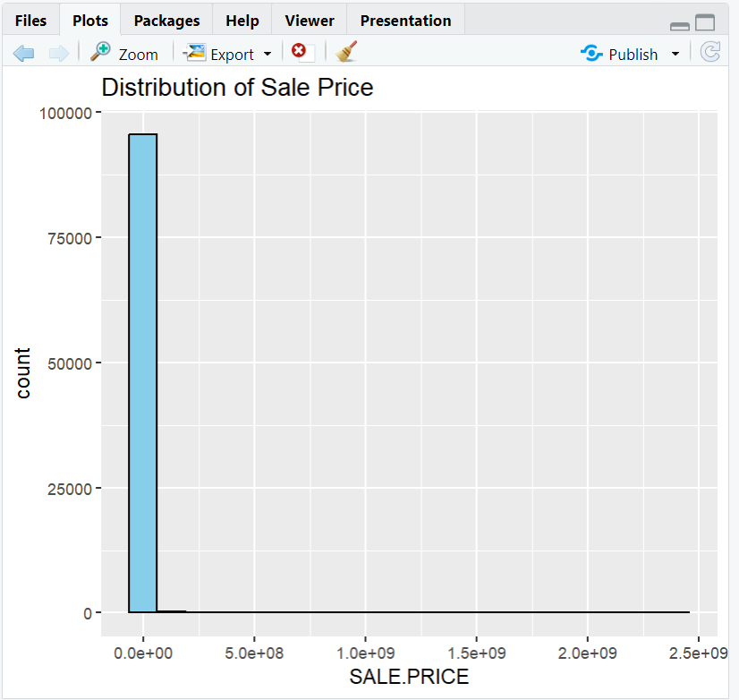
      - To fix this, I tried cleaning out the data to only show the prices greater than 1000. This helped because it got rid of purchases that may have not been real. Though this reduced the amount of entries, the graph was still skewed. I consulted AI and it instructed me to use “scale_x_log10” which compressed larger values and stretches smaller ones.
      - New Graph: 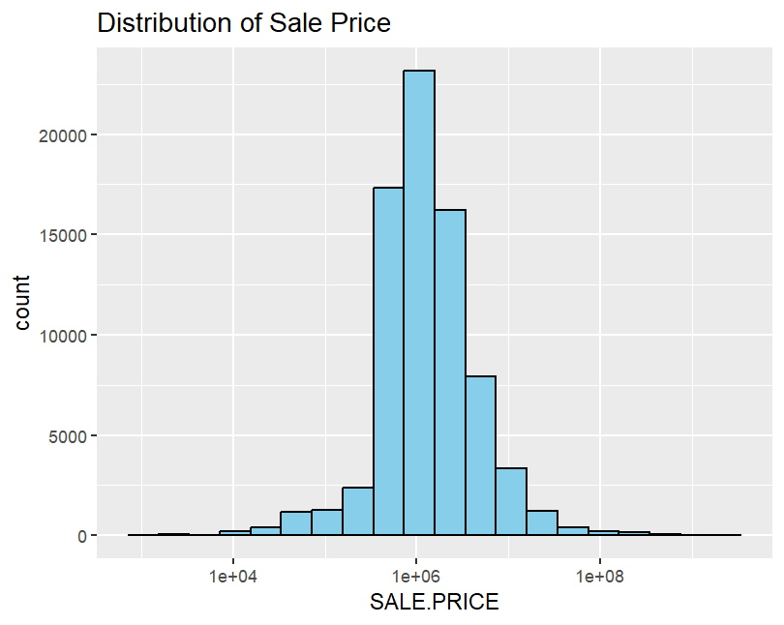
    - Second option – Box Plot
      - I used a box plot because I wanted to see the outliers of sale price in a comprehensive way. However, I ran into the same problem I had with the histogram. The data was very skewed by the very large prices, so I used the same log scaling.
      - 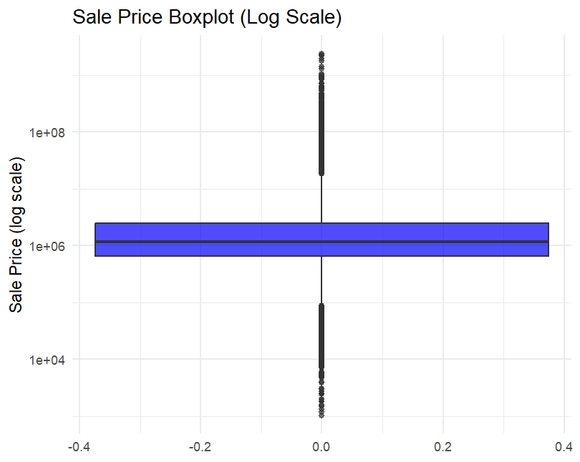
  - Null Hypothesis: There is no correlation between the Sale price and the variable I am analyzing.
Alternate Hypothesis: There is correlation between Sale price and the variable I am analyzing.
    - The first variable I explored was what I initially wanted to analyze, land square feet, and the p-value was very low - p-value: < 2.2e-16. Thus, we reject the null hypothesis.
    - The second variable I explored was zip code, and the p-value was higher than 0.05 – p-value: 0.7713. We fail to reject the null hypothesis.
    - The last variable I explored was the amounts of residential units, and the p-value was very low - p-value: < 2.2e-16. Thus, we reject the null hypothesis.

    - I did have to use clean.manhattan with this because I still wanted to look at prices above $1000.
  - 3 supervised learning models
    - KNN
      - First, I created a new dataset which only includes the numeric columns. I have also cleaned the data by removing every row that contains at least one NA value and by converting the column into a categorical variable. While doing the knn analysis, I realized that the year column is not a numeric value, so I converted all of the values to numeric to make the analysis easier.
      - 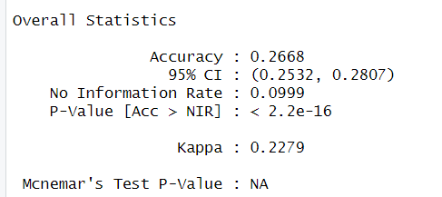
      - Take – away: This model is assigning a neighborhood by looking at the nearest properties (in terms of price, size, land area, and year built). KNN’s accuracy shows us that it is correct around 20% of the time and it is above the no information rate of ~9.9%. This means it is more accurate than guessing, but the neighborhoods overlap in housing features.
    - Random Forest
      - 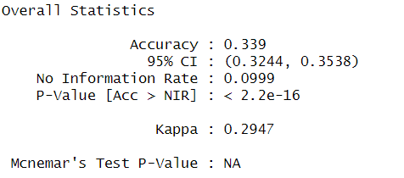
      - Take – away: This model performs the best because it has the highest accuracy rate at ~39%. Random Forest works better because it captures nonlinear relationships and interactions. It is the most stable model for this task.
    - Decision Tree
      - 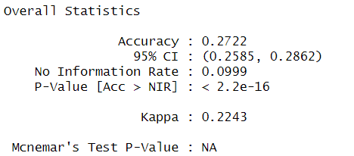
      - Take-away: The decision tree has a similar accuracy rate to KNN at ~27%. This model splits the data using simple “if-else” rules and can’t capture complexity as well as Random Forest. This model is interpretable but not as accurate.
- Borough 2 – Not sure the name
  - Null Hypothesis: There is no correlation between the Sale price and the variable I am analyzing.
Alternate Hypothesis: There is correlation between Sale price and the variable I am analyzing.
    - The first variable I explored was what I initially wanted to analyze, land square feet, and the p-value was very low - p-value: < 2.2e-16. Thus, we reject the null hypothesis.
    - The second variable I explored was zip code, and the p-value was higher than 0.05 – p-value: 0.4088. We fail to reject the null hypothesis.
    - The last variable I explored was the amounts of residential units, and the p-value was very low - p-value: < 2.2e-16. Thus, we reject the null hypothesis.

    - I used the clean data for borough 2 again. I think the reason that square feet and amount of residential units affect the price is because, in general, larger spaces cost more money.
  - Supervised Learning Models
    - KNN
      - I had to filter out ultra-rare neighborhoods before splitting (or combine them), so every remaining class has enough points to appear in both train and test.
      - 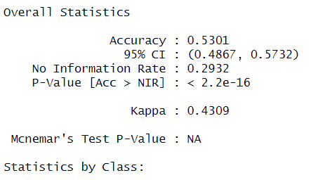
      - Take – away: This model is assigning a neighborhood by looking at the nearest properties (in terms of price, size, land area, and year built). KNN’s accuracy shows us that it is correct around 53% of the time and it is above the no information rate of ~29%. This means it is more accurate than guessing, but the neighborhoods overlap in housing features.

    - Random Forest
      - 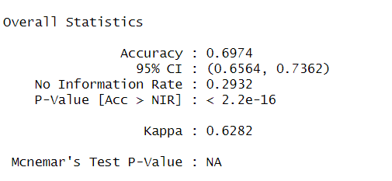
      - Take – away: This model performs the best because it has the highest accuracy rate at ~70%. Random Forest works better because it captures nonlinear relationships and interactions. It is the most stable model for this task.
    - Decision Tree
      - 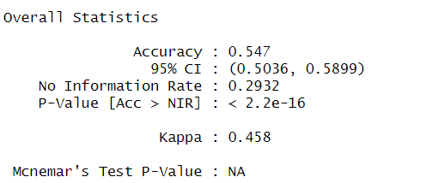
      - Take-away: The decision tree has a similar accuracy rate to KNN at ~55%. This model splits the data using simple “if-else” rules and can’t capture complexity as well as Random Forest. This model is interpretable but not as accurate.
    - I had to clean up this data more than Manhattan because there was less data associated with it. I only kept the neighborhoods with more than 5 rows because the test model would ignore it and mess up the confusion matrix.
  - I am fairly confident in linear model results because I think they make the most sense – price is affected by square footage and size. However, I am unsure if I did the learning models correctly, or analyzed them correctly.

